Name ______________________________ Homework April 24-28
Put your initials by each night that your child practiced the following:
____Monday ____Tuesday ____Thursday
*Nightly Homework*
1. Read Start Right Reader page.
2. Count numbers 1-100.
3. Practice assigned Sight Word list in red reading folder.

Monday: Say each picture. Color the pictures that have a short e sound red and the pictures that have a long e sound green.
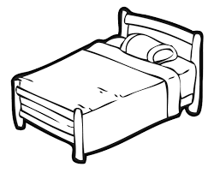 | 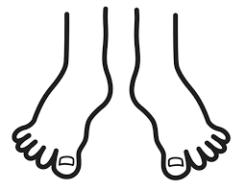 | 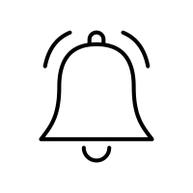
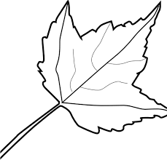 | 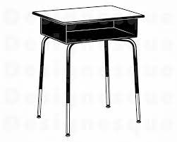 | 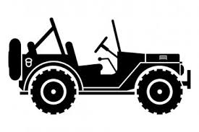

Color a circle for each sound you hear in the word.
pot  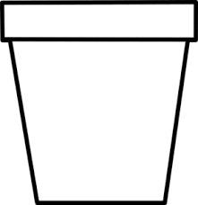 | sun  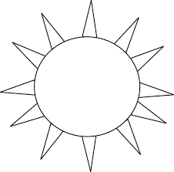 | stem  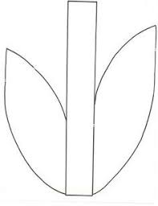 | seeds  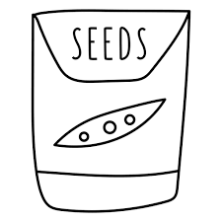

Tuesday: Write each spelling word three times.
van | bat | men | beg | run | tug | sob | on | lid | wig
____  ____ | ____  ____ | ____  ____ | ____  ____ | ____  ____ | ____  ____ | ____  ____ | ____  ____ | ____  ____ | ____  ____
____ | ____ | ____ | ____ | ____ | ____ | ____ | ____ | ____ | ____
Thursday: Circle the medial vowel sound.
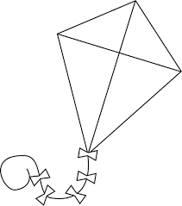  a i e | 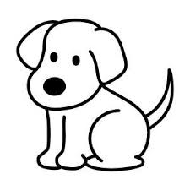  i a o | 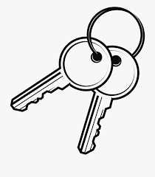  e a u
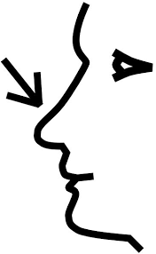  i u o | 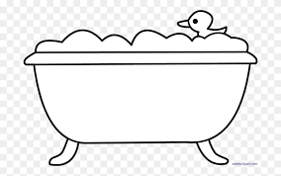  e a u | 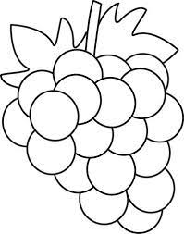  a i e

Color the picture and label the parts of the flower. Write 2 sentences about it.
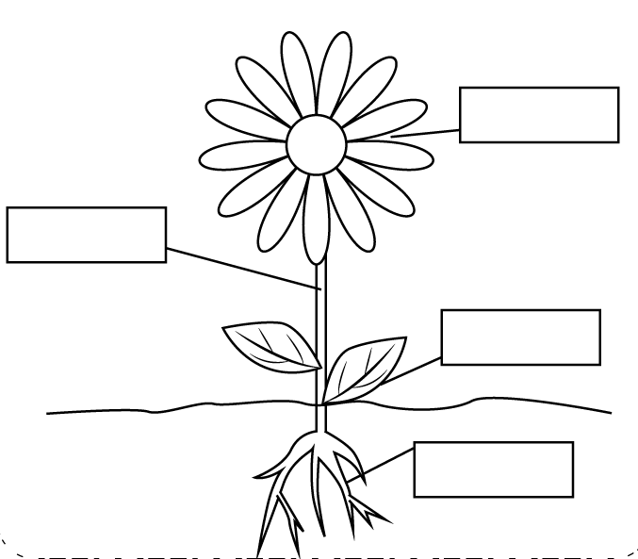
flower stem leaf root

_____________________________________________________________

_____________________________________________________________

_____________________________________________________________

Words to Know

keep made why would eat

Bee Hive
By Lyle Mendoza

The sun is up! Buzz! Buzz! The bee zips from its hive. It will seek buds so it can feed. Buzz! Buzz! Buzz! The bee sees buds. Big buds! It lands on them and sips. The bee speeds back to its hive. The bee made it home! Peek deep in the hive. You will see lots and lots of bees. They feed this big bee. Why would bees do that? The big bee is the queen bee! At last, the sun sets. The bees can stop now. They keep still. It is time to sleep.

Talk about the story and answer the questions:
When does the bee leave the hive? What does the bee do on the buds? What is the bee’s home? What do the bees do in the hive? Who is the big bee? What do bees do when the sun sets?

